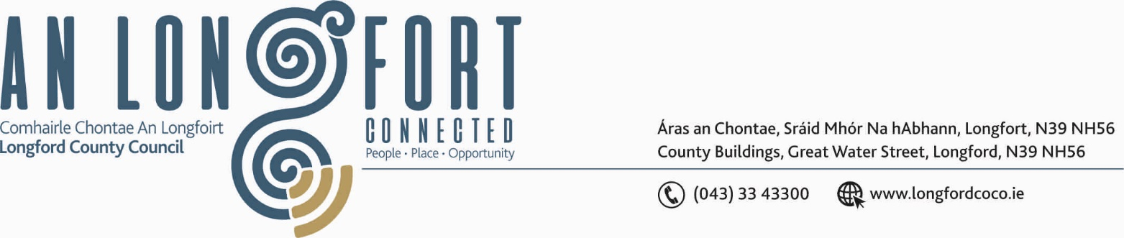

BALLYMAHON MUNICIPAL DISTRICT

14th June 2018.

To: Each Member of the Ballymahon Municipal District.

A Chomhairleoir,

You are requested to attend the Annual Meeting of the Ballymahon Municipal District to be held in The Community Library, Ballymahon on Thursday, 21st June 2018 at 4.30 p.m. to transact business, as set out on the Agenda hereunder.

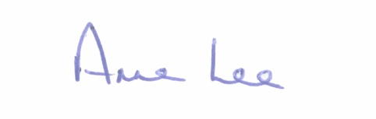
Mise le meas,

_______________
Anne Lee,
Meetings Administrator.

C L A R

1. Election of Cathaoirleach.

2. Election of Leas Cathaoirleach .

3. Fix date and time of Ballymahon Municipal District meetings.

4. Ballymahon-Landevant Twinning Event in Landevant–
1st to 8th September 2018.

